更改保函
REQUEST FOR B/L AMENDMENT
（with shipper’s company letterhead in Chinese & English, 发货人公司的中、英文抬头）

To: Fesco Ocean Management Ltd.,

船名/航次：
(Vessel/Voyage.)
提单号：
(B/L no.)
装运港：
(Port of loading)
目的港：
(Port of discharge)
箱号：
(Container no.)
发货人：
(Shipper)

收货人：
(Consignee)

以上提单数据已经发送贵司, 但以下数据还需要更改：
As per above mentioned shipment's references, the bl data has been transmitted to your company but the following changes have to be made:

例如:
Example:

• Quantity of the goods
NOW READ SHOULD READ
200 cartons 250 cartons

• Weight
NOW READ SHOULD READ
5660 kgs 7075 kgs
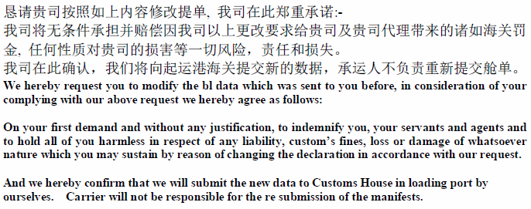

发货人签章处： 订舱代理签章处：
Shipper’s signature (with company’s stamp) Forwarder’s signature (with company’s stamp)

日期：
Issue date

